Subsystem (extraction of the useful blocs for the clutch’s command)

1 Subsystem description
Model of the car. Only the bloc which concerns the clutch's command.

2 System organization
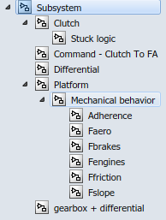
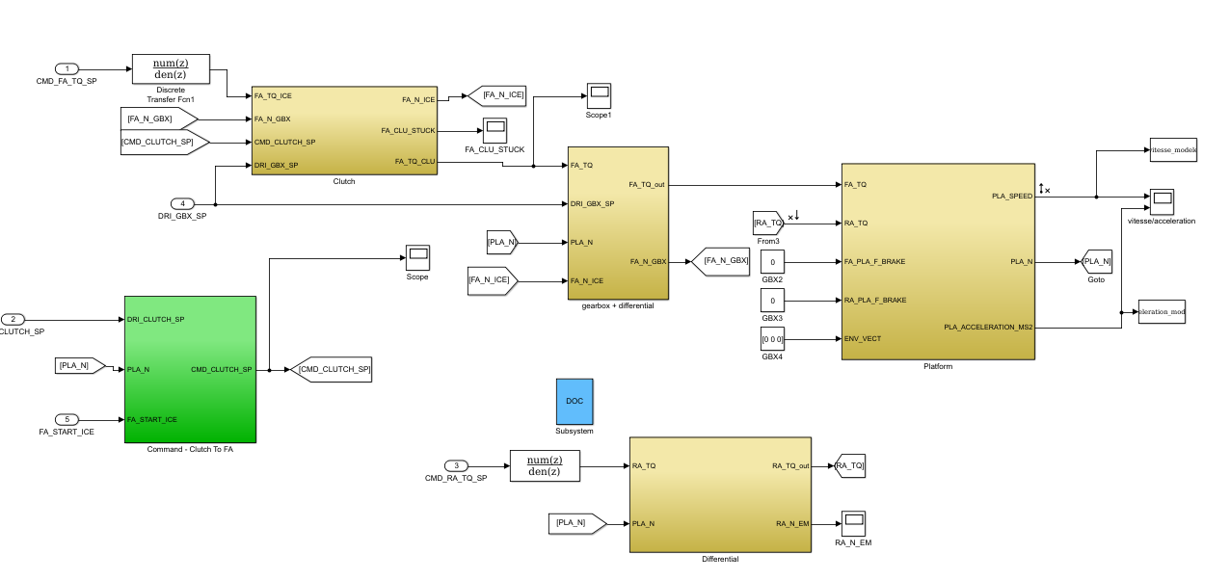

3 Signals and parameters

Inputs

Name | Description | Note
CMD_FA_TQ_SP | Torque set point for the ICE | N.m
DRI_CLUTCH_SP | Clutch pedal value | Range[0,1]
CMD_RA_TQ_SP | Torque set point for the electrical machine | N.m
DRI_GBX_SP | Gearbox engaged gear
FA_START_ICE | Command to start the ICE

Outputs
Name | Description | Note
Speed | Speed of the car | m.s-1
Acceleration | Acceleration of the car | m.s-2

Parameters
Native
None

Inherited
Include all the subsystems

4 Subsystems description

Transfer function of ICE:
We neglect all the losses in the ICE, we only take the transfer function.
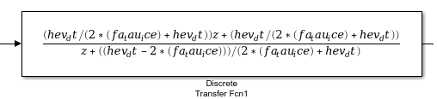

Transfer function of the electrical motor:
We neglect all the losses in the electrical motor, we only take the transfer function.
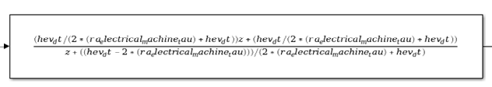

The clutch:
We change nothing in this previous bloc.
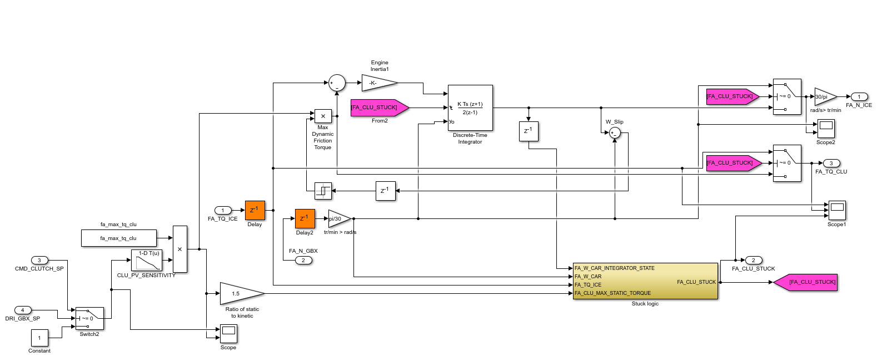

The bloc gearbox + differential:
We change nothing in this previous bloc.

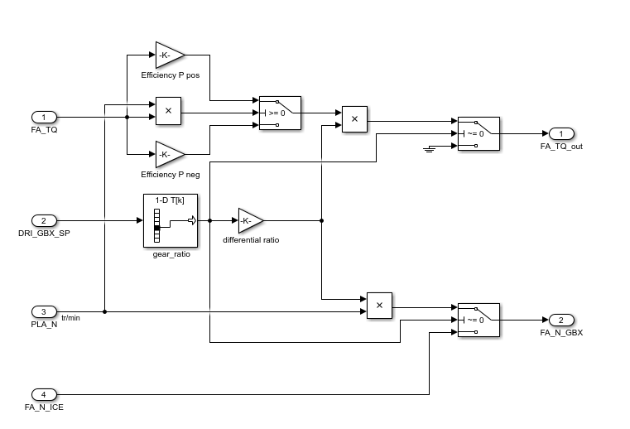

The platform:
We do not use the brake and the ENV_VECT.
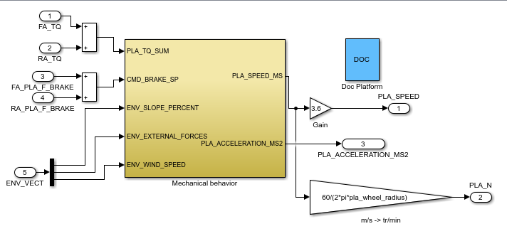

The command of the clutch:
We change nothing in this previous bloc.

